Zavgorodny O. S.
FEATURES OF GEARING OF DRIVES OF NOVIKOV
The evolvent gearing widespread in modern mechanical engineering is linear as contact piece of teeths happens on the line (practically on a narrow platform) located along a cog (fig. 1.1.a) and has hypersensibility to sidesways. This shortcoming can be reduced at pointed contact piece.
Mikhail Leontyevich Novikov (1915 — 1957) offered pointed gearing in which cross-sections of teeths of wheels in face (cross) section are outlined on arches of a circle (fig. 1.1.b). The cog of a pinion gear is carried out convex, and a wheel cog — concave that increases their specified curvature radius, increasing thereby contact strength of drive.
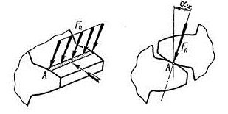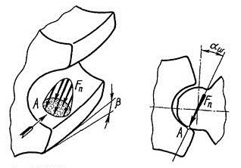
a) b)
Fig. 1.1. Traffic diagram of a contact platform: a) evolvent gearing, b) Novikov's gearing
With a hardness of H ˂ 350HB load ability of drive of Novikov on contact strength is 1,7 times more, than at similar by the sizes and material of evolvent slanting cog drive.
In Novikov's gearing contact piece of teeths happens in a point, and teeths concern only at the time of passing of cross-sections through this point (fig. 1.2.b), and the continuity of drive of the movement is provided with a screw form of teeths. Therefore Novikov's gearing can be only slanting cog with a angle of teeths β = 15... 20 °. The contact point moves along teeths from one edge to another. The position of a contact point of teeths is characterized by its offset from a pole, and the line of gearing is located parallel to a wheel shaft. As a result of elastic deformation and running-in under loading pointed contact piece turns into contact piece on a small platform (fig. 1.2.b). At mutual rolling of teeths the contact platform moves along a cog with the high speed exceeding district speed approximately three times that creates favorable conditions for formation of a steady oil layer between teeths. For this reason the loss on friction in Novikov's drive is much less, and as a result wear is less, life cycle is longer, the reliability of work of drive is more.
Shortcomings of drive of Novikov is dependence of accuracy of gearing on change of interaxle distance, and higher precision of installation of wheels, higher ruggedness of shaft and their bearing parts is as a result necessary; cutting of teeths of a wheel and a pinion gear requires the different tool as they have a different cross-section.
________________________________________________________________________________________________________________________
Work performed under the direction of assistant of the Department of cutting equipment and transportation systems Malininа Yu.V.

