Sukhorukov Arthur
NEW LIFTS AS VERTICAL PUBLIC TRANSPORT SYSTEM
150 years ago, made accessible elevators building skyscrapers; buildings began to rise higher and higher. But now the lifts instead of letting buildings rise – began their limitations; they take up too much space, up to 40% of the building. In the lifts, there were only 3 parameters, which could operate with designers: speed; the size of the cage; number of lifts. A cage in the mine – it's just like a road between the cities with only one train to be very expensive and inefficient. And the higher they go, the harder the cable. When the building sways, the cable begins to wiggle too.
There comes a new time. Engineers from the German company Thyssen Krupp developed a new lift, which is very similar to a vertical train, small trailers go through the tunnels, each in his engine. This is no lift cable. He is like a train, if you miss one, there's another with an interval of 15 to 30 seconds. New lifts can go left, right, up and down.
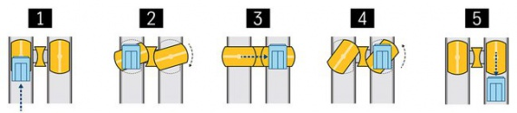
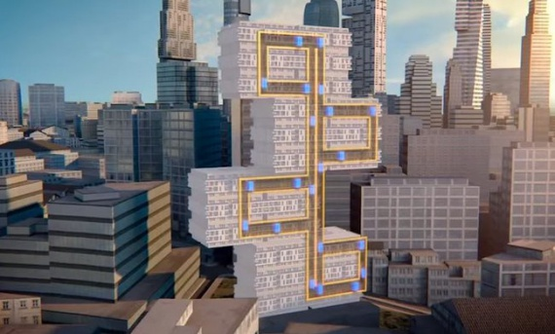 | This concept can radically change the concept of urban development. This system can reduce the area occupied by buildings at 50%. It will also save a lot of time in the construction; because conventional lifts hung from the top of the building, they often install the latest is often delayed delivery of houses in operation. Here the trail of the linear motor is installed with the growth of the building.
In fact, thanks to the new possibilities of horizontal movement, lift cars can go around and now architects unleash hand in the construction of tall buildings or vertical cities. There are many problems associated with the design of lifts. Their cage should be very easy, because the linear induction motors are expensive. It is necessary to develop a new service system, since in such lifts can easily occur in the case of tube breakage of one cage. This will be installed additional tunnels sideline service.
Such lifts are free to serve the lower floors, the upper is constructed. Since the lift can move around the building, it can become part of a new type of public transport system, maneuverable taxi from building to building – it could be a prototype vertical meters.
Now the company Thyssen Krupp identifies three channels in its new 240-meter test tower on this system and will test it for three years. High-rise buildings form a vertical city, and they need a flexible transport system, like the subway. Go to the vertical construction can stop the extensive urban sprawl and keep people close to work and schools, reducing the consumption of energy and energy transportation.
Work performed under the direction of assistant of the Department of cutting equipment and transportation systems Osypova T. N.

