Obushkо A. V.
STUDY WAY TO MEASURE ROUNDING RADIUS CUTTING EDGE AND ITS INFLUENCE ON THE CUTTING PROCESS
It is known that the edge of the cutting tool as the edge on any other object, is the result of the intersection of two surfaces theoretically should be a line. The contour of this line defined the shape and mutual arrangement of the intersecting surfaces.
Real is not always edge line, and in transition surface irregular geometric forms, which are more or less error is identified with a surface having a cross sectional shape of a circular arc with a certain radius of r.
When finishing the processing blade prescribed minimum value serves to reduce the roughness of the machined surface. This reduces the cutting force, the build-up practically not formed decreases processing temperature and increases tool life.
The disadvantages of treatment with low feed is performance drop (partially offset by increased cutting speed), as well as the possibility of vibration, as thickness of cutting layer a It becomes comparable with the radius r rounding the cutting edge.
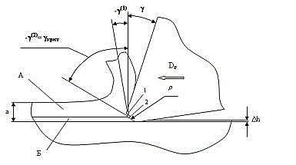
Figure 1.- The process of cutting at the cutting edge radius of rounding ρ
Front angle γ the curved section of the cutting wedge (Fig. 1) is variable and determined by the position of the tangent at the corresponding point. If the front surface is generally positive angle γ, then, for example, at point 1, this angle will be negative. At a certain critical angle
γ _{crit} normal process of cutting it becomes impossible (point 2).
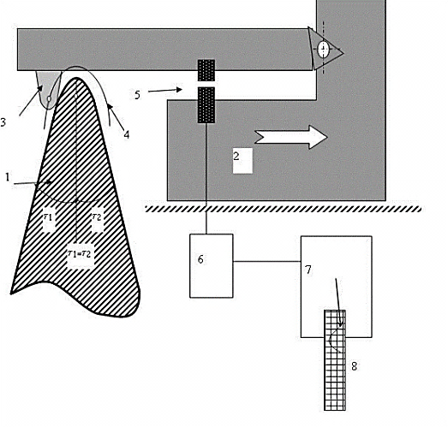
Figure 2.- Diagram measurements rounding the cutting edge ρ
In this case, chips removed only part of the layer a (zone A) and the other part (zone B) deforms the curved part of the blade. After passing through the cutting area elastically deformed layer is restored by the amount Δ h. The value of the maximum permissible angle γ_{crit} = -60^{о}...-70^{о} and determined by the physico-mechanical properties of the processed
material.
In this paper we focus on the measurement of ρ using profiler profiler, as the most simple and leaves the possibility of observing the real-time measurements and on paper.
After installing the cutting edge according to the diagram (Figure 2) - adjusted to the top of the device and removed evidence from the profiler, profiling applied to the template, taking into account the size of the fillet of the needle and is obtained as the result of the radius ρ = Rprofilograms − Rneedle

Робота виконана під керівництвом доц. каф. МОіТС Кондратюка О.Л.

