Habuzov A.K.
TREATMENT-COMPLEX PARTS SUCH AS BODIES OF ROTATION ON THE CNC MACHINES
One of the most common complex profile parts such as bodies of rotation are the details from the screw surface. Typical of this type of parts are rotors of screw pumps.
Existing methods of manufacturing rotors of screw pumps can be divided into two groups: methods based on the use of a turning tool, and methods based on the use of the axial cutting tool. For methods using a lathe tool, is characterized by low productivity and high wear of the cutting edge in comparison with an axial multiblade tool. However, most of the methods that implement the processing axis milling tool, based on the use of mechanical devices with sophisticated kinematics, which limits their application. This lack is not using CNC milling machines. The most time-consuming part of the process in the pre-production of screws in this equipment is the preparation of control programs.
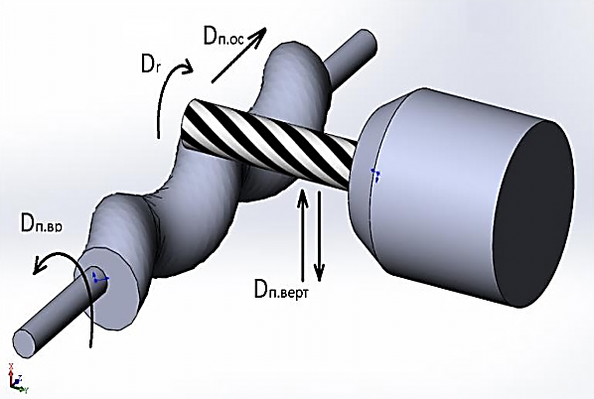
Figure 1 - Diagram of the processing screw rotor axial tool
As the object to develop a control program has been selected with the most common screw geometry «S». Proposed a method in which the shaping of the helical surface is due to the movement of the tool relative to the axis of rotation of the workpiece in the axial and vertical direction, the cylindrical surface of the tool (cutter) at any point in the processing is tangential to the helical surface treated (Fig. 1). In this case, the task of the control system of the machine is to synchronize the rotational movement of the workpiece, axial and vertical feed. Since existing CAD systems do not allow you to organize the processing of the selected scheme, an analysis of the mathematical model of treatment, during which were obtained according to a parametric form for the coordinates of the axis of the cutter during processing 4-axis milling machine equipped with a rotary table.
$$X_{i}=\frac{s∙t}{360}+R∙\sin\left(\frac{360∙e}{h}∙\sin\left(\frac{t∙s}{h}\right)\right);$$
$$Y_{i}=e∙cos⁡(t)+r+R+R\left(cos\left(\frac{360∙e}{h}∙\sin\left(\frac{t∙s}{h}\right)\right)-1\right);$$
$A_{i}=\frac{\left(360+\frac{360∙s}{h}\right)∙t}{360}$,
where A - angle of rotation of the workpiece in degrees; X - coordinate cutter axis relative to the origin in the direction of the axis of rotation of the workpiece, mm; Y - axis coordinate axis of the workpiece relative to the cutter in a vertical (perpendicular to the workpiece axis) direction, mm, t - parameter deg.; s - odacha mm/rev; h - step of the screw e - eccentricity, r - radius of the cross section of the screw, R - the radius of the cutter.
The obtained dependences can be used to control processing program circular helical surface of the cylindrical part of the terminal on a milling machine with a rotary table (coordinate "A").
Робота виконана під керівництвом доц. каф. МОіТС Кондратюка О.Л.

